Multiple-choice section – choose the correct answer

Question 1 [5.1]

The perimeter of a square is 200 cm. What is the length of its side?

A 25 cm B 30 cm C 50 cm D 60 cm

Question 2 [5.3]

A circle of radius 21 cm has a circumference correct to 2 decimal places, of:

A 131.95 cm B 131.99 cm C 132 cm D 133 cm

Question 3 [5.3]

A semi-circular protractor of radius 9.5 cm has a perimeter correct to 2 decimal places, of:

A 33.13 cm B 29.85cm C 41.13 cm D 48.85 cm

Question 4 [5.4]

A parallelogram of area 30 cm2 and height 3.5 cm has a base length of:

A 2.32 cm B 4.78 cm C 8.57 cm D 6.55 cm

Question 5 [5.4]

A trapezium has an area of 312 cm2. If its parallel sides are 12 cm and 28 cm long, its height is:

A 6.6 cm B 22.4 cm C 4.9 cm D 15.6 cm

Question 6 [5.5]

A circle with an area of 90 cm2 has a radius correct to 2 decimal places, of:

A 5.35 cm B 5.53 cm C 3.90 cm D 3.91 cm

Question 7 [5.6]

The total area of a shape formed by joining a 8.5 cm square to a 15 cm by 6.5 cm rectangle is:

A 72.25 cm2 B 169.75 cm2 C 97.5 cm2 D 132 cm2

Question 8 [5.3]

$\sqrt{144}-3^{2}×(1-3)$ The area of the triangle below is 76 cm2. If the base is 4 cm, what is its height, *h*?

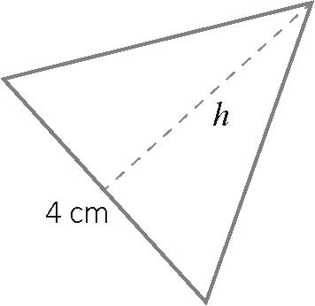

A 10 cm B 13.5 cm C 23.5 cm D 38 cm

Question 9 [5.7]

A rectangular prism has a volume of 724 cm3. If its height is 7 cm and its width is 10 cm,   
what is its length?

A 4.87 cm B 6.11 cm C 9.23 cm D 10.34 cm

Question 10 [5.8]

Alana started a marathon at 8:33 am and finished at 12:57 pm. The time that she took was:

A 3 hours 54 minutes B 4 hours 9 minutes C 4 hours 24 minutes D 4 hours 19 minutes

Multiple-choice results: ___ / 10

Short answer section

Question 11 4 marks [5.1]

Find the perimeter of each shape, in cm.

(a)

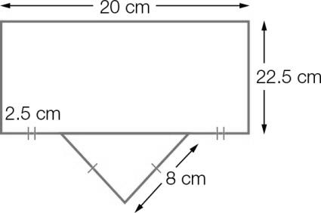

(b)

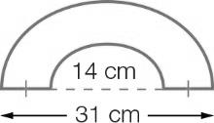

Question 12 2 marks [5.1]

Find the perimeter of a regular hexagon with edge length 8.5 cm.

Question 13 7 marks [5.1]

Find the perimeter of each of these shapes.

(a)

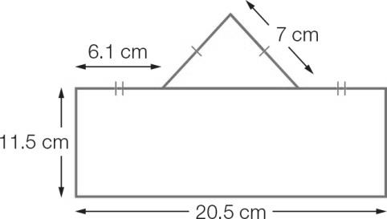

(b)

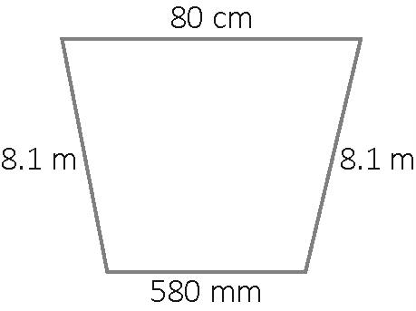

(c)

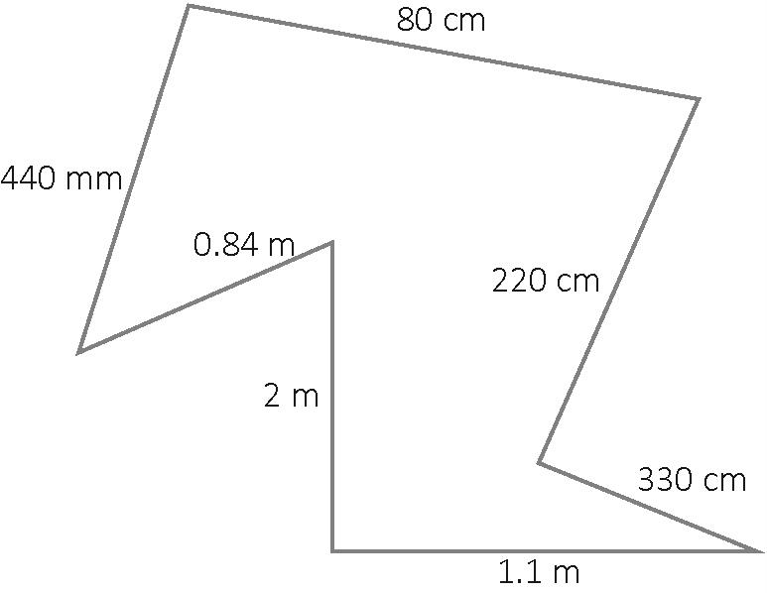

Question 14 2 marks [5.2]

The circumference of a circle with radius of 14 cm is 87.96 cm. Find the ratio of the circumference of the circle to the diameter of the circle and state the symbol used for that ratio.

Question 15 4 marks [5.3]

Find the perimeter of each shape to the nearest centimetre.

(a)

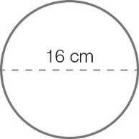

(b)

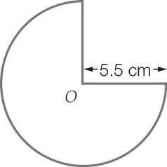

Question 16 2 marks [5.4]

Find the area of a parallelogram that has a base length of 33 cm and a height of 10 cm.

Question 17 2 marks [5.4]

Find the area of the trapezium.

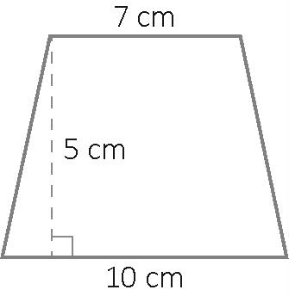

Question 18 2 marks [5.4]

Find the area of the following shapes.

(a)

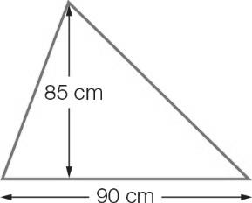

(b)

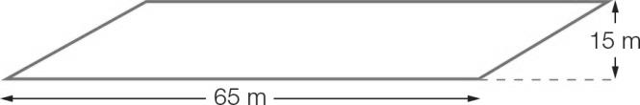

Question 19 2 marks [5.5]

Find the area of the circle.

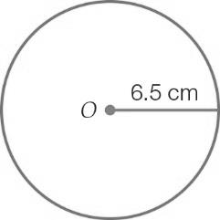

Question 20 2 marks [5.5]

Find the area of this shape correct to 2 decimal places.

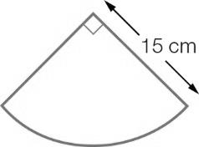

Question 21 3 marks [5.4, 5.5]

Lin has a cake recipe that says to use a 30 cm diameter round cake tin, but he only has rectangular tins. He has a 30 cm by 35 cm tin and a square 30 cm tin.

Which one should he use? Show all working.

Question 22 3 marks [5.6]

Find the area of the following figure.

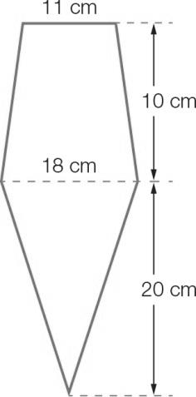

Question 23 4 marks [5.6]

Find the area of the following figures, in cm2 correct to 2 decimal places.

(a)

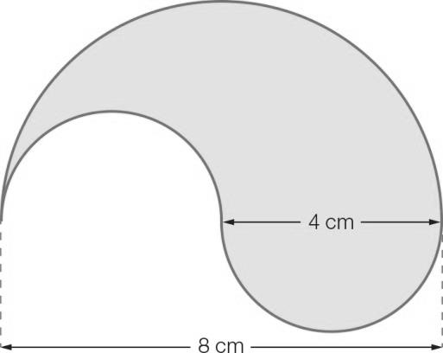

(b)

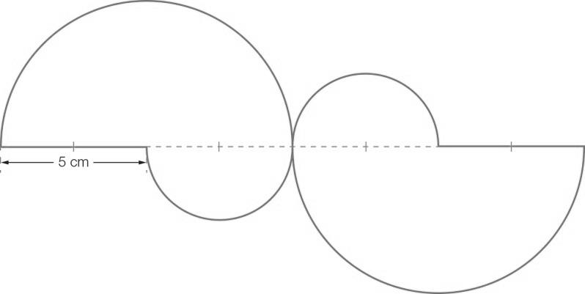

Question 24 3 marks [5.7]

How many litres of water can the cylinder below hold? Give your answer correct to 2 decimal places

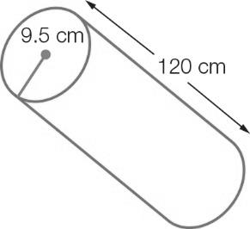

Question 25 5 marks [5.8]

Imogen arrived at school at 8:43 am after taking a 40-minute tram ride from home. The first lesson started 11 minutes after she arrived at school. Recess, following the first three lessons, was 150 minutes later. Recess lasted 25 minutes. Two lessons, each of 70 minutes, followed recess and then it was lunch time. Use the information to find:

(a) the time that Imogen caught the tram to get to school

(b) the time that recess started

(c) the time that lunch started.

Short answer results: ___ / 49

Extended answer section

Question 26 5 marks [5.6]

The design for an irregular shaped workbench is shown below. The material for the benchtop costs $1500 per square metre.

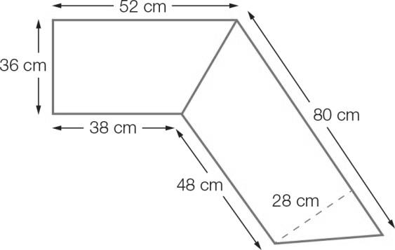

(a) Find the area of material needed to make the workbench.

(b) What is the total cost of the benchtop?

Question 27 5 marks [5.5]

A dartboard is shown below. The circles are of radius 4 cm, 8 cm, 12 cm, 16 cm and 20 cm.   
The areas labelled *A*, *B*, *C*, *D* and *E* are rings; they do not overlap.

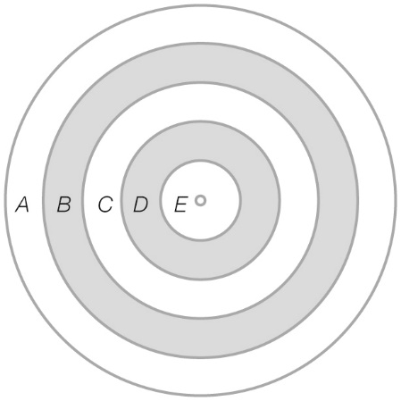

(a) How many times larger is the area of ring *D* than *E*?

(b) The area of which circle is equal to the area of *B* and *C* added together?

Question 28 6 marks [5.6]

In the equilateral triangle below there are 10 billiard balls which just touch each other and the inside of the triangle. The radius of each billiard ball is 5.5 cm. The sides of the equilateral triangle are   
48.3 cm long and its height is 50 cm.

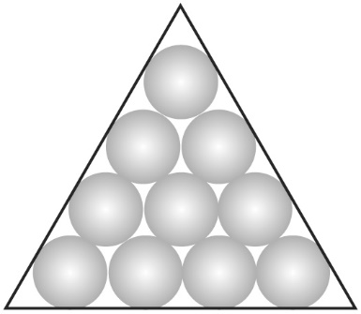

Find:

(a) the area of the triangle

(b) the area taken up by the 10 billiard balls

(c) the area of the triangle not used by the billiard balls

(d) the number of billiard balls that could fit into this unused space if it was available separately.

Question 29 5 marks [5.7]

The diagram below shows a view from above of a swimming pool that Jimmy plans to construct.

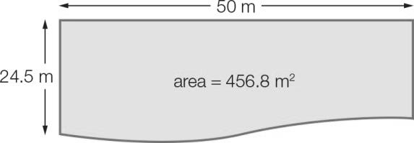

(a) The pool has a depth of 7 m. Calculate the volume of the pool.

(b) Calculate how much water the pool can hold in litres correct to 2 decimal places.

Extended answer results: ___ / 21

TOTAL test results: ___ / 80